**Curriculum Policy**

**Contents**

1. Halliwell Mission 3

2. Halliwell Intents 3

3. Background 3

4. Timetable 3

5. Curriculum Intent 4

6. What do we want pupils to learn? 6

7. What is academic success? 6

8. What do we mean by Pupils’ Personal Development? 6

9. Our Curriculum 7

10. Reading across the curriculum 7

11. Curriculum delivery – implementation 8

12. How our Curriculum will be delivered 9

13. Planning and Expectations of Planning 10

14. Designing a knowledge-rich curriculum: 10

# Halliwell Mission

‘To provide the best quality of education and care for vulnerable children through a vibrant curriculum which fully prepares pupils for their future economic wellbeing and nurture outstanding personal development.’

# Halliwell Intents

* Empower
* Aspire
* Enjoy
* Respect
* Transform

# Background

Our school is an independent special school, which is part of Halliwell Homes. We will provide education for pupils aged 5 to 14 years who have suffered significant trauma and have attachment difficulties. Many pupils will have limited positive experiences of school and may be working below age related expectations. Most pupils will have an Education, Health and Care Plan (EHCP) and will have experienced significant disruption in their education and/ or home lives. All pupils will be looked after, in our own Ofsted registered children’s residential homes. All pupils will have access to a broad and balanced curriculum with the school day running from 9am to 3pm. Pupils will learn in small groups. Many will receive significant support, to enable them to progress towards working independently and as part of a group. All pupils will have a full-time education programme. Our school will be a positive, well-resourced place to learn and work. Our staff will be proactive in challenging perceived derogatory views about the legally protected characteristics, as set out in the Equality Act 2010, of age, disability, gender reassignment, marriage and civil partnership, pregnancy and maternity, race, religion or belief, sex and sexual orientation, through exploration of, and development of mutual respect for those different to themselves.

1. **Timetable**

Our timetable is designed to ensure that all pupils have access to a broad and balanced curriculum which includes all aspects of the National Curriculum across all Key Stages.

Most of our pupils have a range of social, emotional and mental health (SEMH) difficulties, these may have been identified in their Education and Health Care Plans (EHCP). We have the capacity in school to be adaptable and flexible to respond to the needs of the pupils’ whilst maintaining their entitlement to a broad and balanced curriculum that covers all requirements of the Independent School Standards. The development of the timetable ensured that interventions are embedded opportunities to prevent learners from further lost learning opportunities, across the curriculum, whilst addressing current gaps in learning.

The structure of the timetable, as above, allows pupils to have breaks between sessions to allow them to re-focus and transition from one subject to another, reintegrating them to learning without losing valuable education time.

Example timetable

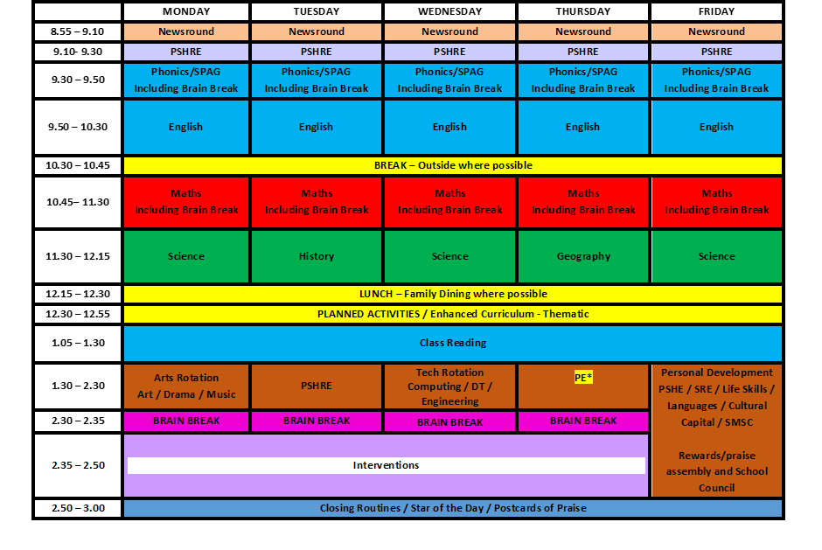

# Curriculum Intent

Halliwell Homes seeks to promote a curriculum that is accessible to all our pupils, and which enables them to achieve as highly as possible and to experience academic as well as personal success. We have high aspirations and expectations of all pupils. Our curriculum provides the means through which our vision ,focus and aims will be realised. We intend to provide breadth and balance in our programmes, to motivate pupils who are disaffected to re-engage with education and to embrace the concept of lifelong learning. They should leave our school with a range of experiences, skills and knowledge which will act as currency, providing them with a solid foundation for success in life It will cover Key Stages 1 to 3 and be adapted regularly to reflect changing emphasis and statutory guidance.

We want to be sure our pupils are clear about what we are teaching and why. We also need to be able to measure outcomes to be sure we are maximising success for all learners; therefore, our planning, monitoring and evaluation is systematic, collaborative and linked to the school development plan.

We want our pupils to acquire knowledge and learn new skills, but we realise that there needs to be carefully designed to allow time for and opportunities to address pupils’ often complex needs for the time that they are with us and also to prepare them for the time when they will leave.

We aim to:

• deliver a broad, balanced and ambitious curriculum, based on the National Curriculum, differentiated as is appropriate to individual pupil’s needs and interests.

• provide a framework for teaching and learning, within which there is flexibility and scope for this adaptation and creativity to take place.

• ensure high quality teaching and learning experiences for all pupils.

• support pupils’ needs and requirements so they can access, enjoy and succeed in school. • provide the experiences and skills pupils need to be well prepared for their next stage of life; for further education, employment and to play active and fulfilling roles in society.

• ensure staff are well supported to deliver our curriculum by providing continuing professional development, guidance and support to deliver excellent education and support for pupils.

As our cohort of pupils change due to the nature of the Halliwell Homes Restorative Parenting Programme, we will modify our curriculum to meet their needs and interests. As such, the curriculum will be kept under at least annual review. Part of our review will include:

I. what we intend pupils to learn

II. the effectiveness of the range of teaching activities we use to implement our curriculum

III. the impact of the curriculum, i.e. how well the content is learned by pupils, as evidenced by their overall progress and outcomes.

# What do we want pupils to learn?

Our curriculum will support pupils to:

• gain the knowledge they need to achieve the overall goals of their education as set out in their EHCP, as agreed upon admission, or identified and agreed as progress and needs are reviewed.

• gain the knowledge and skills which will be most important for their life chances. This will be based on their individual needs, difficulties and diagnoses, as well as strengths and interests.

• remember and recall learning as they make progress through the Key Stages and subjects.

• know the personalised targets, which help them to achieve the overall goals of their education.

• have high aspirations for their future, by learning about different careers, gaining employability skills, and preparing pupils for the world of work.

• develop self-respect, a positive self-perception and resilience, by understanding their own health and well-being, and how to manage their emotions and behaviours effectively.

• develop spiritual, moral, social, cultural awareness and British Values; preparing them well for independent living in the local community and in modern Britain.

• embrace difference and diversity, including protected characteristics, through gaining a good awareness, understanding and developing respect for others.

• understand their rights and responsibilities and be able to express their views appropriately.

# What is academic success?

Staff will support pupils to develop:

• to understand, embrace and manage their individual diagnoses, challenges and talents of the skills and knowledge they need to ‘close the gap’ with peers elsewhere

• academic success, which is pertinent to their own possibilities and passions

# What do we mean by Pupils’ Personal Development?

Pupils will be supported through opportunities to promote and develop:

* positive attitudes and behaviour for learning
* effective learning and study skills
* social communication, emotional literacy and self-regulation
* working memory skills
* self-awareness, keeping safe, healthy, fit and well.

1. **Our Curriculum**

Our Curriculum at Key Stage 1, 2 and 3 (Years 1 to 9) As appropriate to pupils’ needs, we will provide learning in the following subjects:

* + English – Phonics in KS1 and KS2 where appropriate
    - reading and writing components
  + Maths
  + Science; including elements from Biology; Chemistry and Physics
  + Humanities, including History and Geography
* Technology - Design and Technology, including Food Technology and computing
  + Arts – Art, music and drama
  + Physical Education (PE)
  + Personal, social, health, citizenship and economic education (PSHRSE) incorporating Relationships, sex and health education (RSHE)

We believe that where staff find regular opportunities for recognition, pupils become can taste success and become accustomed to achieving well in all subjects. Most pupils will leave with a desire to work hard, achieve and succeed. This will prepare them well for the demands of a community-based school, whether that be specialist or mainstream provision, as well as becoming independent and succeeding in life beyond school.

# Reading across the curriculum

We place a high priority on reading and recognise that it is a vital skill for life, on both a practical level and for pleasure. We focus on nurturing a love of books and learning to read at all Key Stages.

Pupils will have several opportunities daily to read, including dedicated reading time, in lessons, at break and lunchtime, as well as choosing books from an appropriate range to read at home. Parents and Carers will be encouraged to listen to their children read daily and provide feedback to staff. Staff will focus on how best to support individual pupils to make rapid progress in reading, as soon as they join our school.

For pupils who find reading more challenging, our staff team will provide extra support to enable them to catch up. Depending on pupils’ starting points and SEND, this might start with developing pupils’ awareness of sound before moving towards providing lessons in phonics. This will help pupils to read with increasing confidence and fluency. As pupils move through the school, they will explore a range of ambitious texts in English lessons and more widely, as appropriate.

Parents and Carers will be supported to continue to encourage their children to reading, e.g. reading more specialist articles about current affairs, leisure or sport.

# Curriculum delivery – implementation

The curriculum will be delivered in a way that best meets pupils’ needs.

Teaching Hours and Timetabled Lessons

Our school will be open for a minimum of 195 days per year, which includes 5 INSET training days for the staff team. Pupils will be required to attend school for a minimum of 190 days per year. See our School Term Dates and Holidays – available on our website.

We are passionate about supporting pupils to fulfil their potential and recognise that every minute spent in school should be valuable. Therefore, pupils will have a full-time programme of learning. These hours include Form Time, Assemblies, intervention times, break and lunchtimes, which are all valuable learning times where pupils can develop a range of social, emotional and behavioural skills with support from and under the watchful eye of staff.

Class Sizes and Staff Support

Class sizes will be small, and many groups might have two, three or four pupils. Pupils will be supported by high ratios of staff which will support effective curriculum delivery. Some pupils might need to work more independently or with additional support in some or all lessons. This might include having a bespoke timetable that take account of strengths and areas of need. Individual interventions are planned as required to support us to close gaps in knowledge and skills, helping pupils to make more rapid progress.

Our staff team are suitably qualified and experienced. Teaching staff, including Teaching Assistants will be deployed to ensure effective curriculum delivery and to maximise support to meet pupils’ individual needs. All staff will have completed the Halliwell Homes Restorative parenting programme induction training which will ensure therapeutic approaches are embedded within the support provided by the staff team.

New Pupil Admissions

Pupils joining our school will undergo a range of assessments and observation, as appropriate, during their first 6 weeks. This will help staff to understand their needs and identify strategies to support engagement and appropriate learning. This initial period also ensures that there are no previously unidentified needs. Following this, close collaboration between school staff and any clinicians working with a pupil will support us to tailor provision so that it will meet their needs effectively.

Transition Plans

Transition Plans will be implemented for all new pupils, supporting them to integrate smoothly into the school. We will support pupils to move at a good pace towards full-time education on the school site, if this is not appropriate from day one. We recognise that pupils will have a diverse range of needs, experiences and difficulties. Some may have anxiety, a history of school refusal, leading to poor attendance at school for significant periods of time. Induction and transition to the school will be bespoke and based on the individual pupils’ needs.

Transition plans will be constructed in the same manner for pupils transitioning to a community-based school and these will be shared with both school and home staff to ensure a smooth and successful transition.

# How our Curriculum will be delivered

Pupils will be challenged and supported to achieve the best possible outcomes and make progress throughout each Key Stage. This will be achieved through high quality teaching of skills, knowledge and vocabulary. The Head of Education will select the most appropriate subject matter for our pupils. The Head of Education will support staff to produce Curriculum overviews and detailed Schemes of Work to ensure that the content for each Key Stage is covered appropriately. Staff will be able to identify any gaps in pupils’ knowledge and ensure these are covered appropriately, preparing pupils for the next phase of learning and supporting them to catch up with peers nationally. Teaching staff will select high quality resources and a range of teaching methods within and outside of the classroom to bring each subject to life. Staff will ensure teaching and resources are appropriate to each pupil’s age, needs, ability and interests.

The curriculum will be delivered:

* through logically sequenced lessons, which support pupils to build on prior knowledge and make connections.
* by staff who help pupils to remember what they learn and ensure that they make progress in all subject areas.
* in an interesting and inspirational way, helping pupils to develop enjoyment of learning, by helping them to experience success and achieve positive outcomes.
* in a way that supports pupils to be ready for the next stage of learning and life beyond school.

# Planning and Expectations of Planning

All schools are working towards having a shared curriculum, in order to support staff workload and wellbeing, as well as ensuring that the curriculum diet is of the highest quality and quality assured by subject specialists from across the Education Team.

Long Term Plans will be mapped out for the academic year, by subject and by class group with an overview of the themes and topics which will be studied across the year.

Sequencing and interleaving and weaving of knowledge, skills and understanding should be mapped across the academic year, across the two years that pupils will access Halliwell Education, so that, when they leave us, they have the very best skills, knowledge and understanding in order to support them with the next steps of their education – wherever this may be.

# Designing a knowledge-rich curriculum:

**Teacher Walkthrough’s Page 48 - 65**

The principles of designing a knowledge-rich curriculum and the lessons that a woven through it are a cognitive process – a reflective process. It is not a form-filling exercise. It is important to always consider the bigger picture and consider, ***WHY THIS, WHY NOW?*** What knowledge are our pupils starting this process with and what is it that you want them to take away.

**Peps McCrea states, *‘Planning is best viewed as a process, rather than a product. As a stack of habits of thought that you bring into play to prepare yourself for teaching.’***

1. Let knowledge drive the philosophy: The more pupils know, the more they can learn.
2. Consider a range of knowledge forms:

**Declarative:** What are the key facts that all children should know?

**Procedural:** What are the things that all children should be able to do?(skills)

**Experiential:** What knowledge can only be gained first-hand be experiencing or doing certain activities?

1. Specify the knowledge in detail: What is the exact knowledge you want to include and specify what the pupils should know in as much detail as possible.
2. Sequence and map the knowledge coherently: Sequence the information in a few different forms so that there is a coherent flow, building on secure foundations, staged step-by-step building towards challenging goals.
3. Teach knowledge to be remembered, not just encountered: Plan the sequencing and the elements that you will regularly return to, supporting the building of knowledge over time, feeding previous topics into current topics supported by **PRACTICE AND RETRIEVAL** strategies.

